Implementation Approach

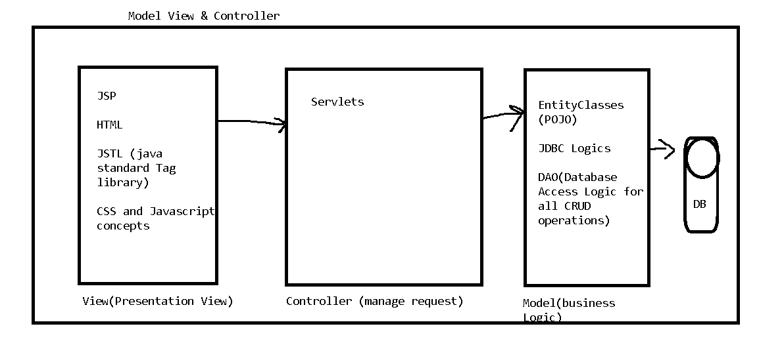

Another way to implement Capstone Project

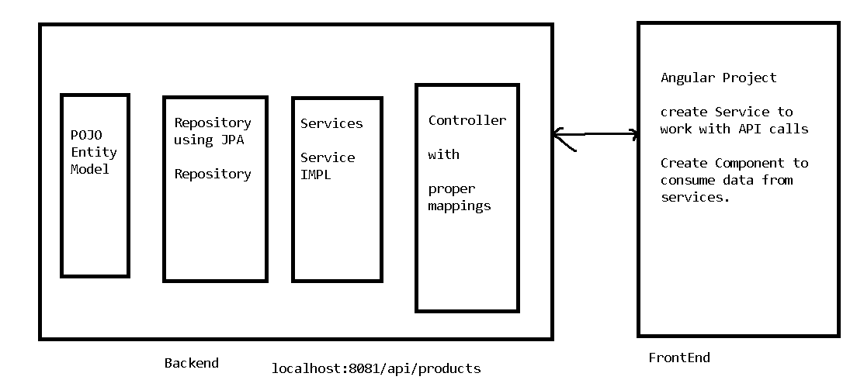

Project No 1:

Medicare: Online ordering of Medicines.

Application is having 2 users

1. Customer
2. Admin

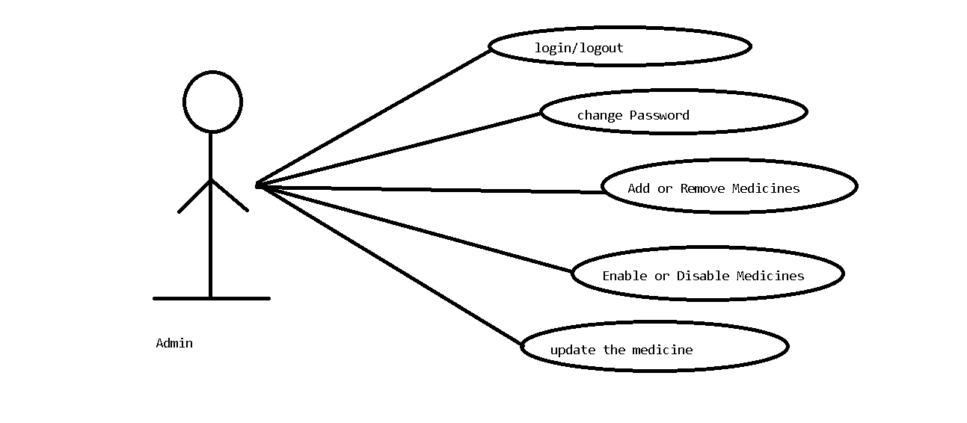

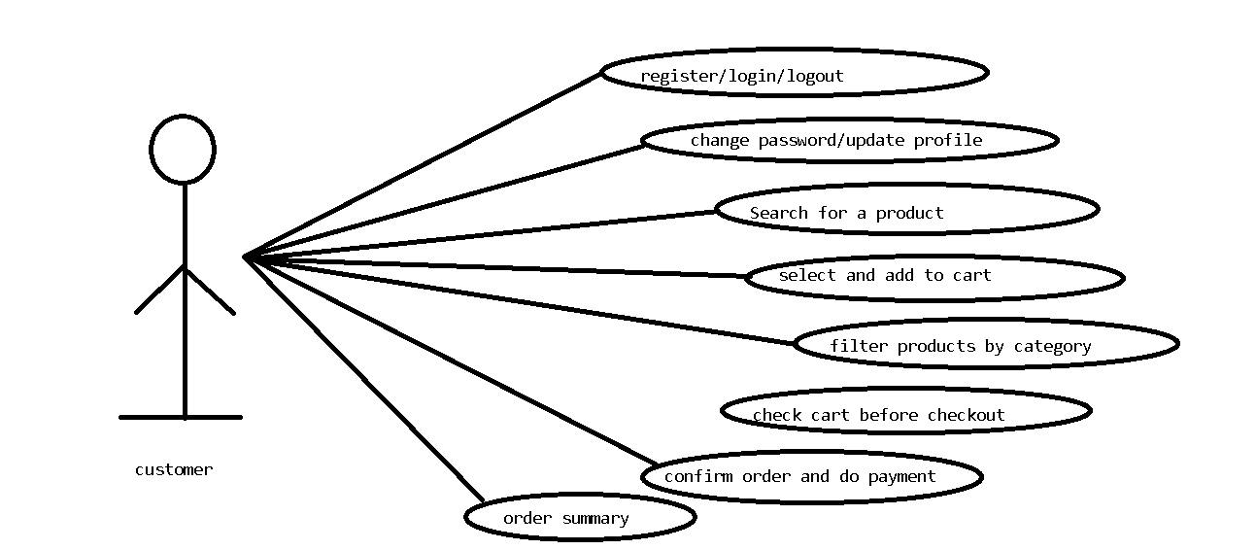

**Customer Perspective View**

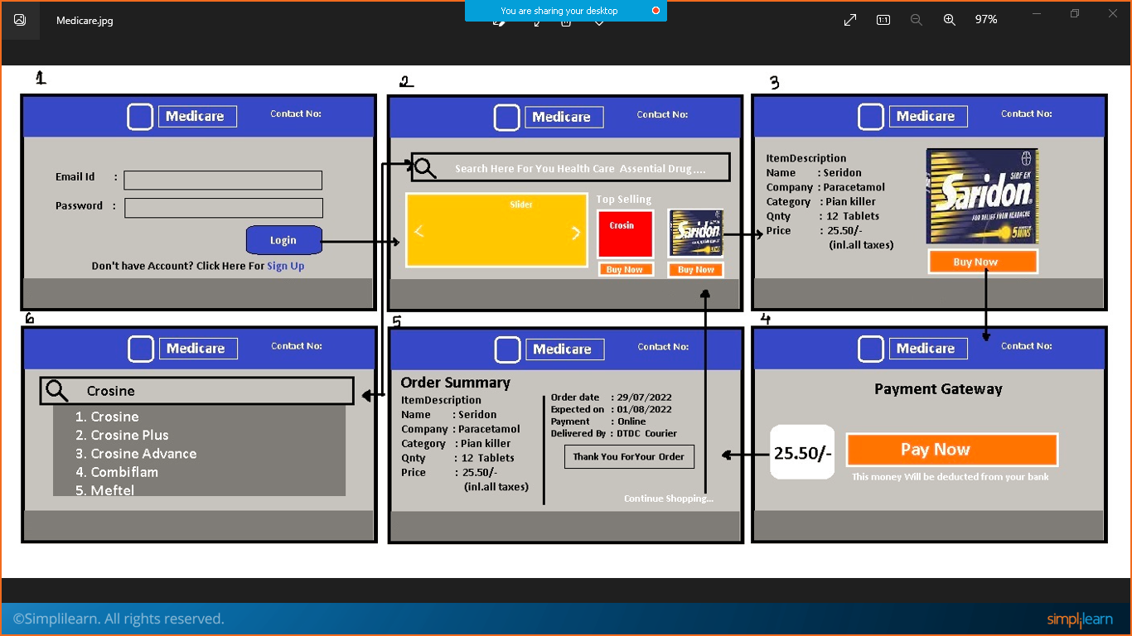

Admin Perspective

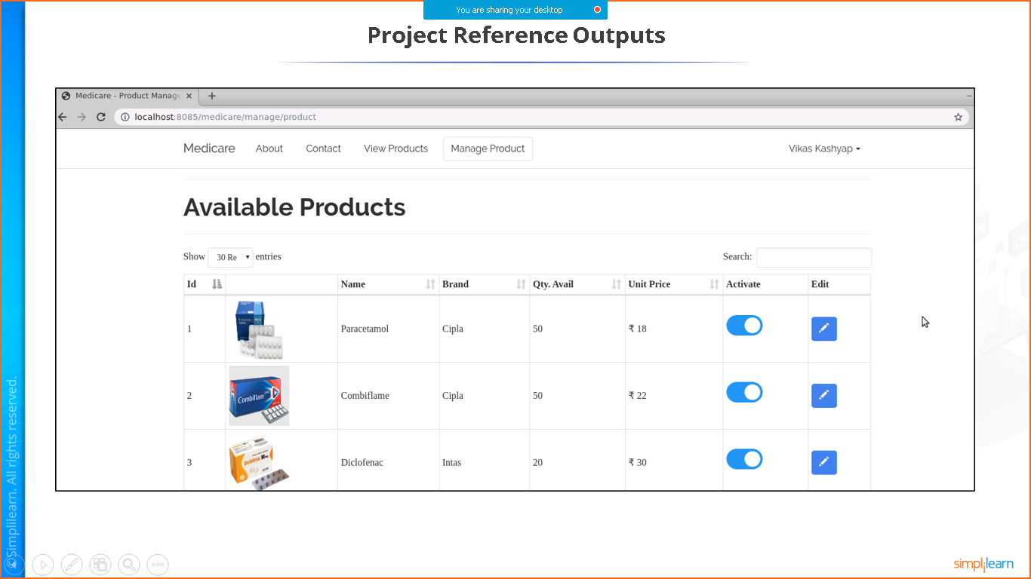

**Add Product**

You can also provide delete button near to edit.

When you click on Add product it will open Form for adding product.

For active- you can make field int- 0 means deactivated & 1 means activated.

Application No2: FoodBox

Online Ordering of Food Items.



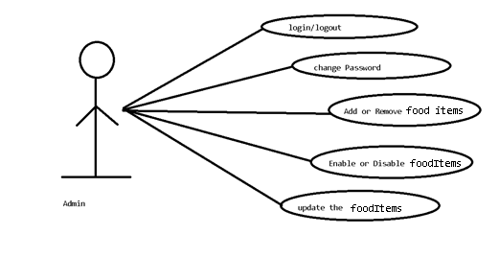

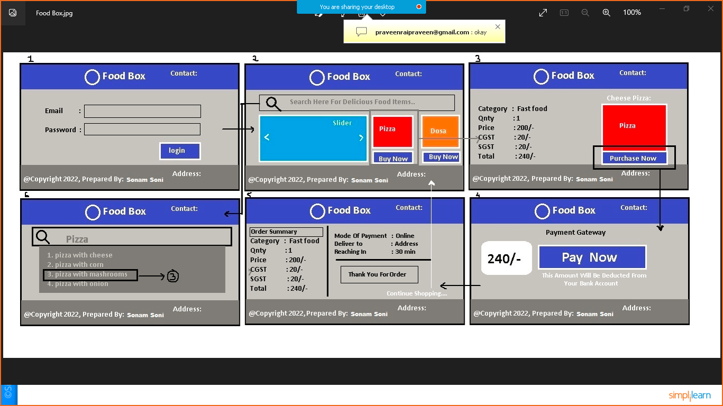

Application No3: NMS Cinemas

Booking Movie Tickets Online.

Application No4: ICIN Bank

Online Banking